

**Flood Safety Messages**

# **The rainy season is here! Be alert! Exercise caution! Stay safe!**

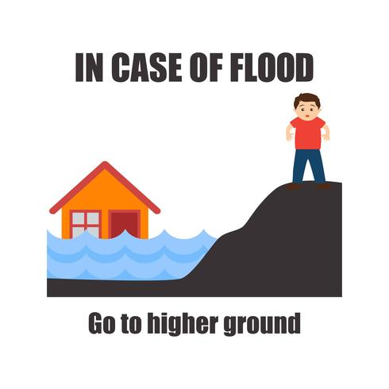

IN CASE OF FLOOD Go to higher ground

1. **Keep children indoors when it is raining!**
2. **Do not allow children to play in flooded areas!**
3. **Conduct regular headcounts of your family members!**
4. **Maintain appropriate hygiene practices to prevent disease!**
5. **Do not drink flood water. It can make you sick!**
6. **Watch your step! Flood waters often hide sharp and dangerous debris like glass or metal!**
7. **Do not pick up strange objects from flooded areas! They might be dangerous!**
8. **Stay off of flooded bridges! Avoid crossing flooded streams or any pool of water!**
9. **Evacuate when told to do so.**
10. **Return home only when told it is safe!**